1 install laravel

2 starter kit

3 dashboard tamplate use

3.1 create admin & front folder in pubic

3.1.1 put image, css, js, vendor folder in pubic\admin

3.2 create admin & front folder in resources\views

3.2.1 create dashboard.blade.php file in admin folder & copy code from index.html

3.2.2.Create layout folder & 4 files as shown below

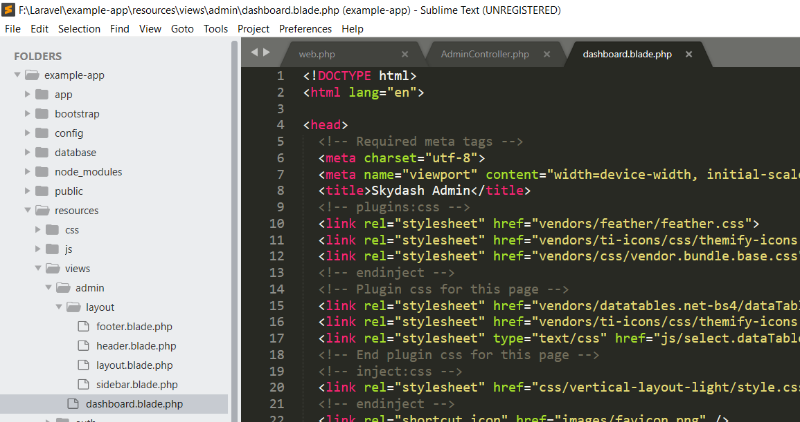

3.3 create AdminController in app\app\Http\Controllers\Admin



3.3 create Admin & Front folder in app\app\Http\Controllers

Then create dashboard route

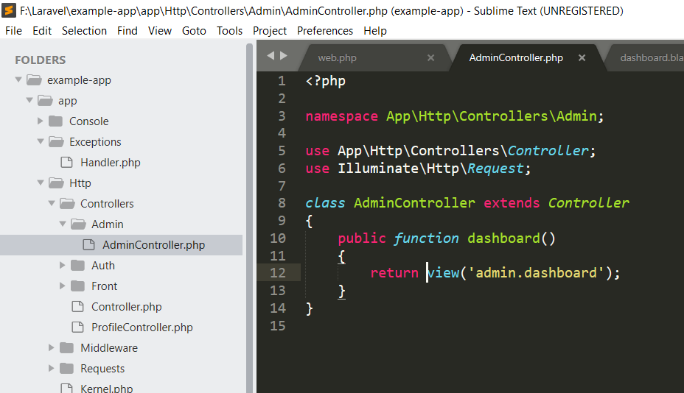

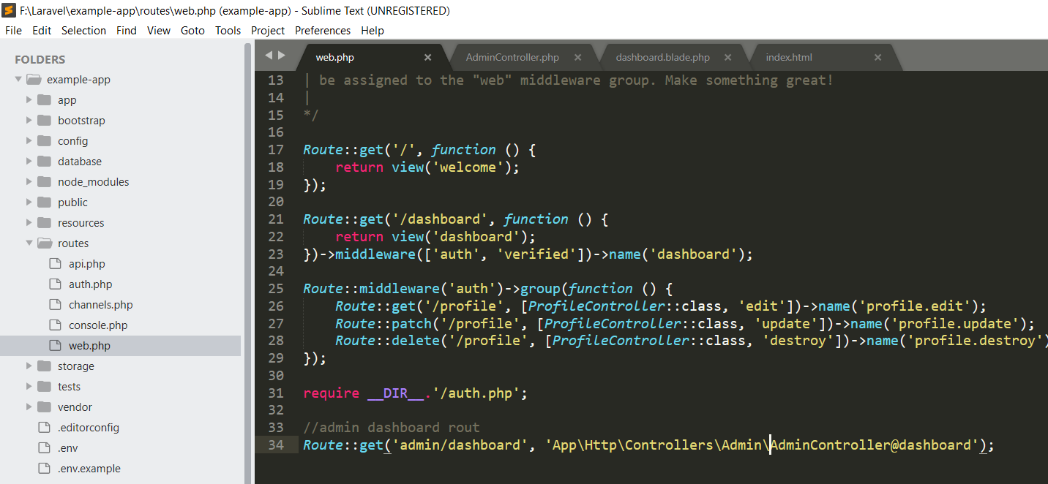

3.4 slice the code

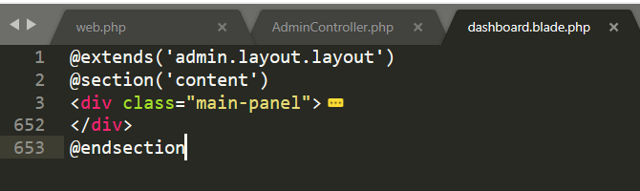

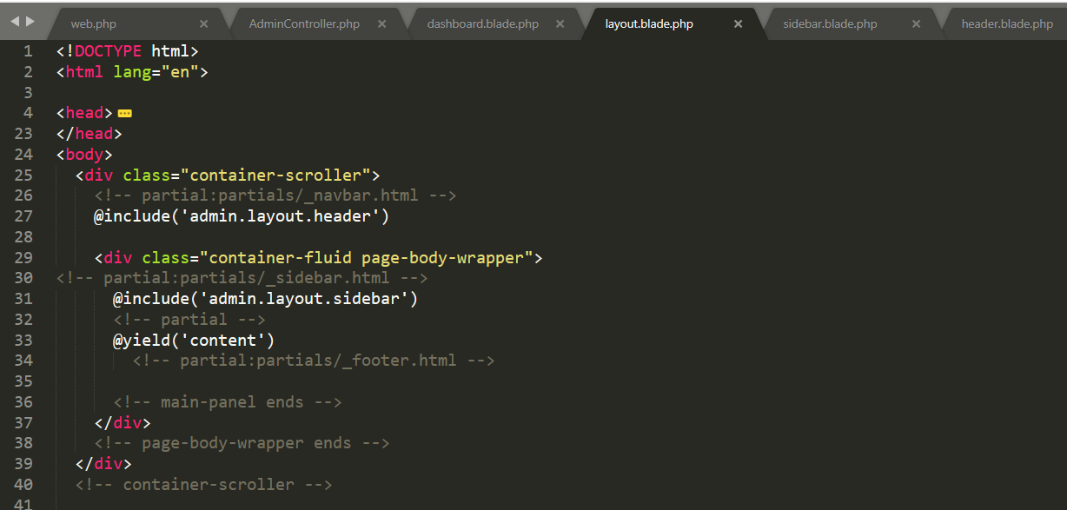

3.5 Add url && asset

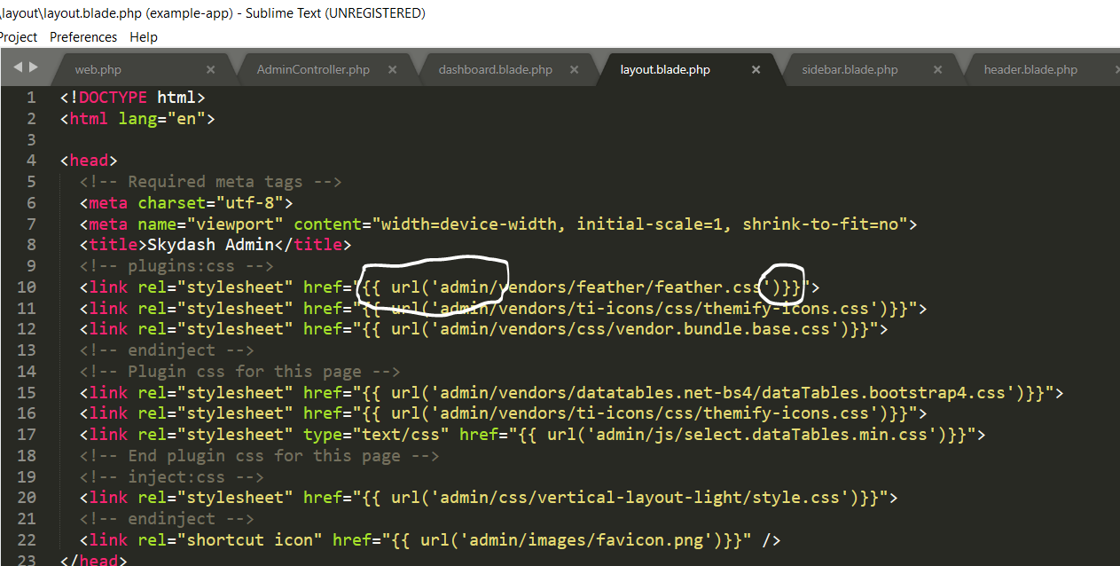

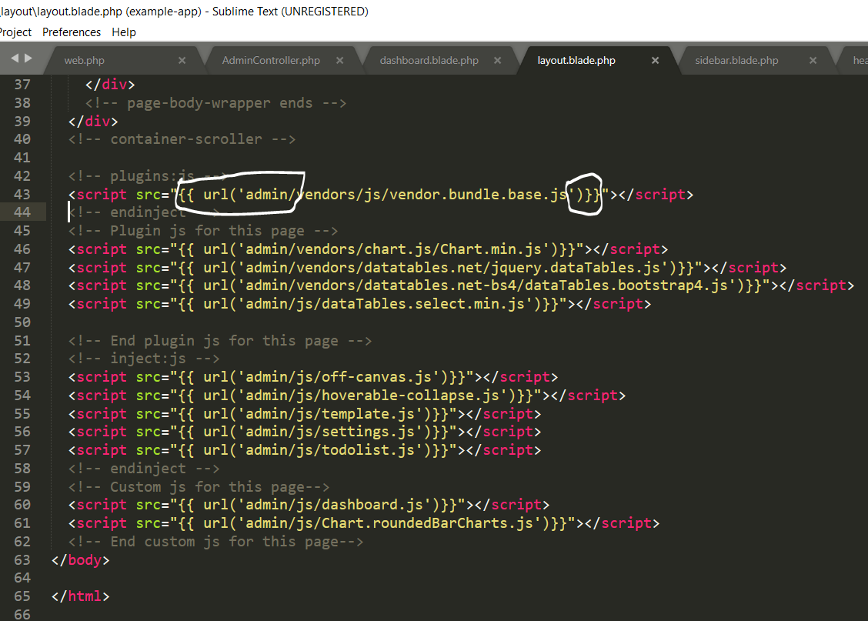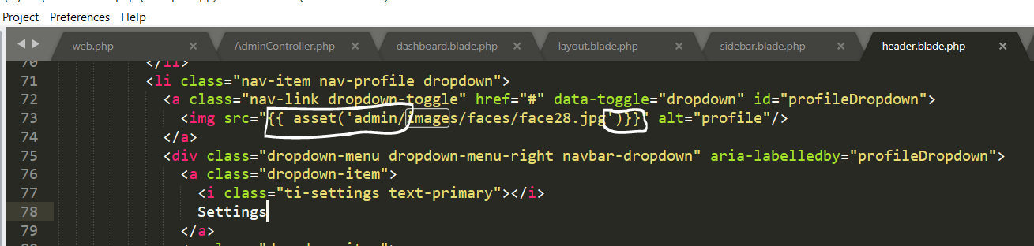

**Tutorial 6: Create a vendors table & model**

F:\Laravel\example-app>php artisan make:migration create_vendors_table_vendors_table

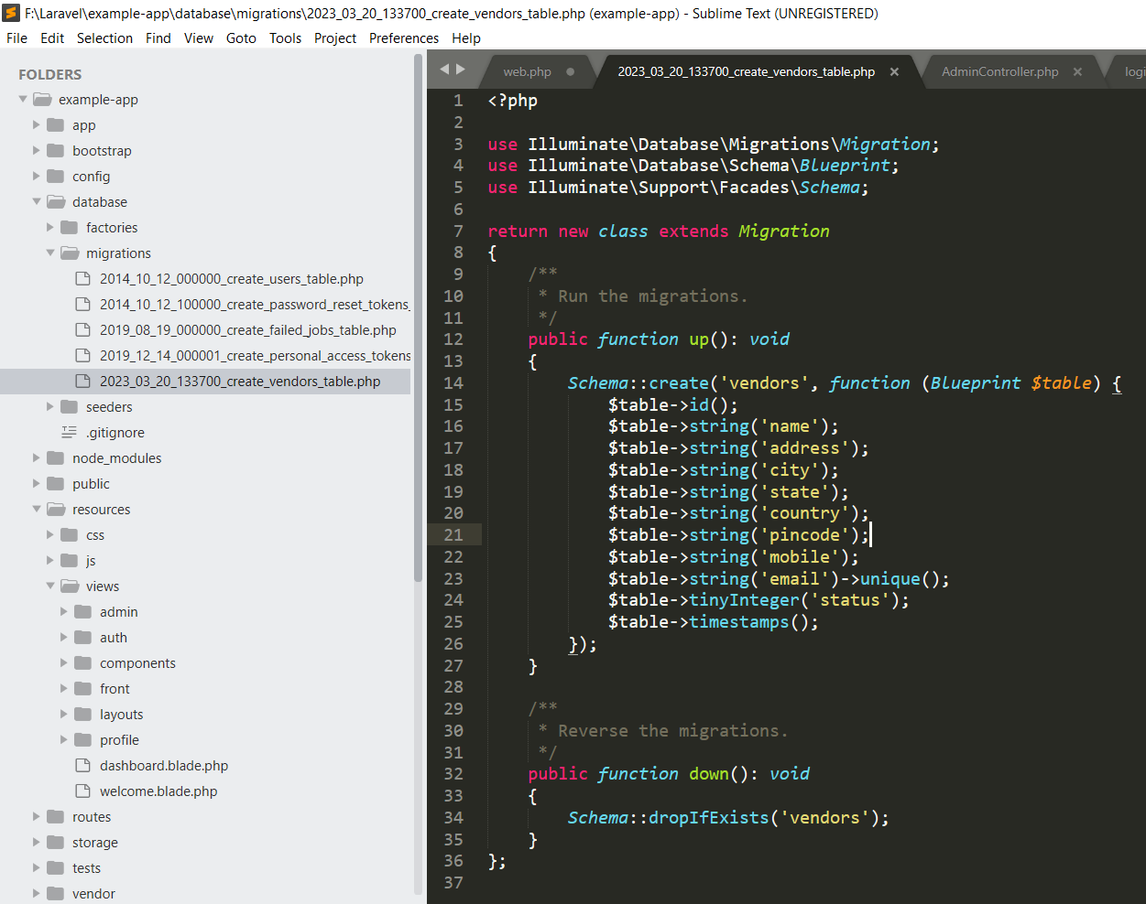

F:\Laravel\example-app>php artisan migrate

F:\Laravel\example-app>php artisan make:model Vendor

**Create a admins table, model**

F:\Laravel\example-app>php artisan make:migration create_admins_table vendors_table

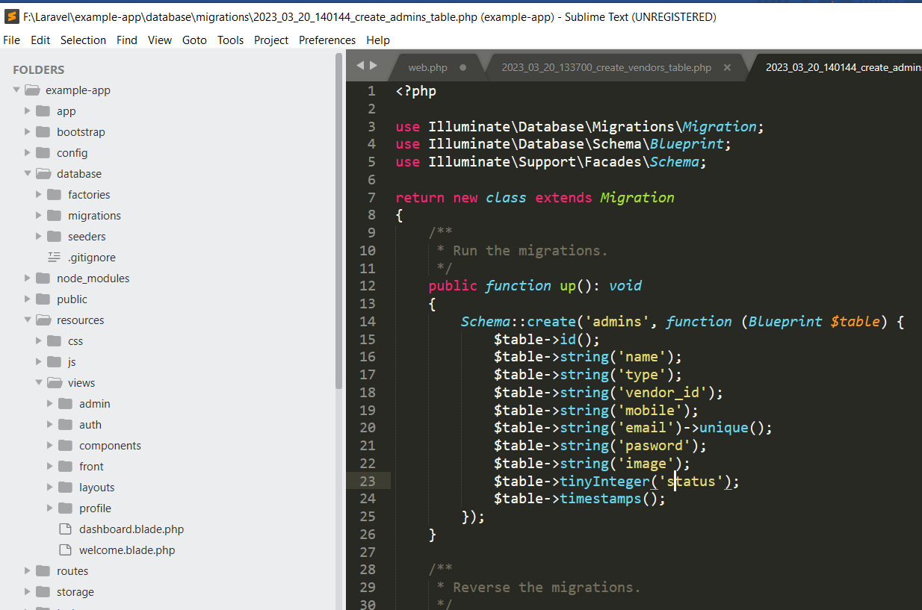

F:\Laravel\example-app>php artisan migrate

F:\Laravel\example-app>php artisan make:model Admin

**Tutorial 7: Create**

**Tutorial 8: Create**

**F:\Laravel\example-app>php artisan make:seeder AdminsTableSeeder**

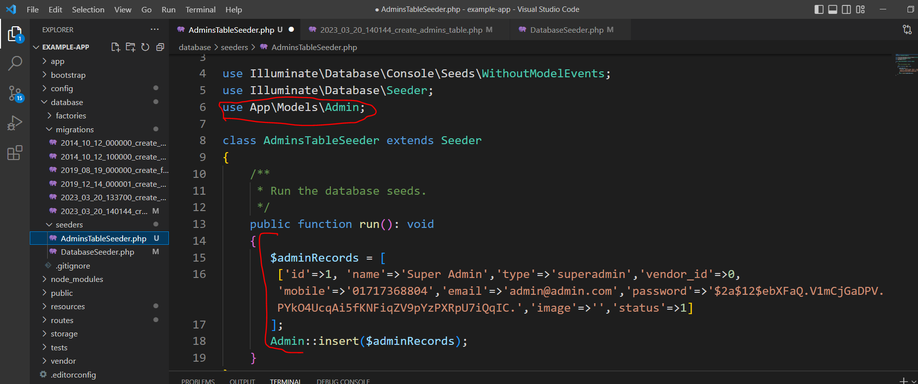

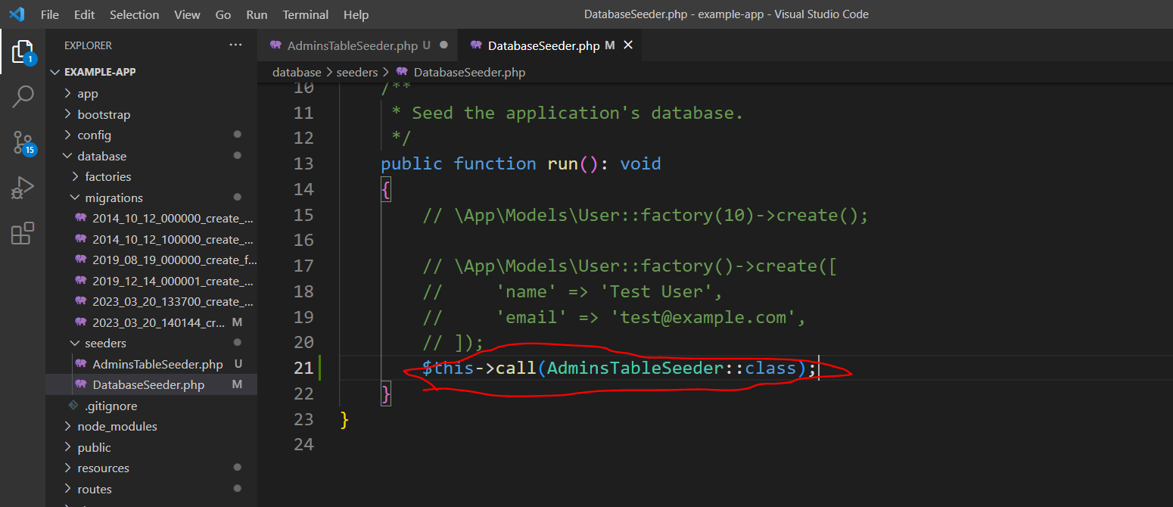

PS F:\Laravel\example-app> composer dump-autoload

PS F:\Laravel\example-app> php artisan db.seed

**Tutorial 9**

Admin login and logout